Create a RestAPI Server using MySQL
Here is a comprehensive guide to building a production-ready Expense REST API using Node.js, Express, and MySQL (mysql2/promise). This implementation includes database connection pooling, proper async/await handling, input validation, and secure parametrized queries. [1, 2, 3]

Exercise Steps:
- You need to have MySQL Data Engine and WorkBench GUI ready for this exercise. To prepare, follow the guide from the following link:
https://ckleng.azurewebsites.net/Common/Setup/InstallMySQL

- Prepare data for the MySQL server
- Start workbench from Windows button
- Sign-in using root account
- Run the following SQL (DDL) commands to create a new database and table
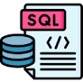
CREATE DATABASE IF NOT EXISTS expense_tracker;
USE expense_tracker;

CREATE TABLE IF NOT EXISTS expenses (
id INT AUTO_INCREMENT PRIMARY KEY,
title VARCHAR(255) NOT NULL,
amount DECIMAL(10, 2) NOT NULL,
category VARCHAR(100) NOT NULL,
expense_date DATE NOT NULL,
created_at TIMESTAMP DEFAULT CURRENT_TIMESTAMP
);
- To set up your project, open your terminal, create a new directory for your project, and initialize it:

C:\>cd/
C:\>cd Angular
C:\Angular>md RestAPIMySQL
C:\Angular>cd RestAPIMySQL
C:\Angular\ RestAPIMySQL>code .
Now, you have opened the application in VS Code
- mysql2 for performance and modern Promise/async support, and dotenv to protect database credentials..In VS Code terminal:

npm init -y
npm install express mysql2 dotenv cors

- Configure Environment Variables
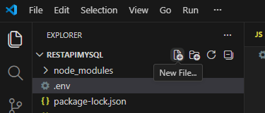

Paste the following code into your .env file

PORT=3000
DB_HOST=localhost
DB_USER=root
DB_PASSWORD=your_password
DB_NAME=expense_tracker
- Create the Database Connection Pool
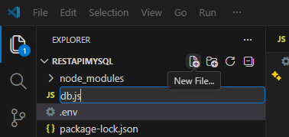
Paste the following code into your db.js file
// db.js
import mysql from 'mysql2/promise'; // Using promise-based client
import dotenv from 'dotenv';

dotenv.config();

const pool = mysql.createPool({
host: process.env.DB_HOST,
user: process.env.DB_USER,
password: process.env.DB_PASSWORD,
database: process.env.DB_NAME,
waitForConnections: true,
connectionLimit: 10,
queueLimit: 0
});

export default pool;
- To use modern import syntax, ensure you add "type": "module" to your package.json file
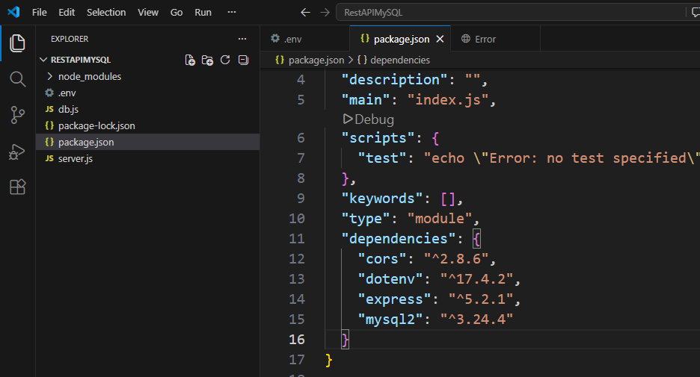
- Build the Server and API Endpoints.
Create a file named server.js. This script acts as your application's entry point, initializing the server and defining the CRUD (Create, Read, Update, Delete) routes. [1, 2]
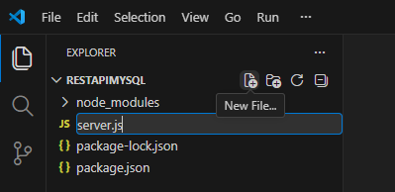


// server.js
import express from 'express';
import cors from 'cors';
import pool from './db.js';

const app = express();
const PORT = process.env.PORT || 3000;

// Middleware
app.use(cors());
app.use(express.json()); // Parses incoming JSON payloads

// 1. CREATE an Expense
app.post('/api/expenses', async (req, res) => {
const { title, amount, category, expense_date } = req.body;

if (!title || !amount || !category || !expense_date) {
return res.status(400).json({ error: 'All fields are required.' });
}

try {
const query = 'INSERT INTO expenses (title, amount, category, expense_date) VALUES (?, ?, ?, ?)';
// Securely pass variables via placeholder array to prevent SQL injection
const [result] = await pool.execute(query, [title, amount, category, expense_date]);

res.status(201).json({
message: 'Expense added successfully',
expenseId: result.insertId
});
} catch (error) {
res.status(500).json({ error: error.message });
}
});

// 2. READ All Expenses
app.get('/api/expenses', async (req, res) => {
try {
const [rows] = await pool.execute('SELECT * FROM expenses ORDER BY expense_date DESC');
res.json(rows);
} catch (error) {
res.status(500).json({ error: error.message });
}
});

// 3. READ a Single Expense by ID
app.get('/api/expenses/:id', async (req, res) => {
const { id } = req.params;
try {
const [rows] = await pool.execute('SELECT * FROM expenses WHERE id = ?', [id]);
if (rows.length === 0) {
return res.status(404).json({ message: 'Expense not found' });
}
res.json(rows[0]);
} catch (error) {
res.status(500).json({ error: error.message });
}
});

// 4. UPDATE an Expense
app.put('/api/expenses/:id', async (req, res) => {
const { id } = req.params;
const { title, amount, category, expense_date } = req.body;

if (!title || !amount || !category || !expense_date) {
return res.status(400).json({ error: 'All fields are required for updates.' });
}

try {
const query = 'UPDATE expenses SET title = ?, amount = ?, category = ?, expense_date = ? WHERE id = ?';
const [result] = await pool.execute(query, [title, amount, category, expense_date, id]);

if (result.affectedRows === 0) {
return res.status(404).json({ message: 'Expense not found' });
}
res.json({ message: 'Expense updated successfully' });
} catch (error) {
res.status(500).json({ error: error.message });
}
});

// 5. DELETE an Expense
app.delete('/api/expenses/:id', async (req, res) => {
const { id } = req.params;
try {
const [result] = await pool.execute('DELETE FROM expenses WHERE id = ?', [id]);
if (result.affectedRows === 0) {
return res.status(404).json({ message: 'Expense not found' });
}
res.json({ message: 'Expense deleted successfully' });
} catch (error) {
res.status(500).json({ error: error.message });
}
});

// Start Server
app.listen(PORT, () => {
console.log(`Server running on http://localhost:${PORT}`);
});

- Run the API
To launch your server, execute this command in your terminal:
node server.js
You will see Expense API Server running on: http://localhost:3000

- Testing the REST API Endpoints
You can evaluate the functionality of your application using any REST client (e.g., Postman) or directly from your command-line interface using curl commands (Use new Terminal): [1]

- Create Expense (POST)
curl -X POST http://localhost:3000/api/expenses -H "Content-Type: application/json" -d '{"title": "Grocery Shopping", "amount": 75.50, "category": "Food", "expense_date": "2026-09-17"}'

- Get All Expenses (GET)
curl http://localhost:3000/api/expenses

- Delete Expense (DELETE)
curl -X DELETE http://localhost:3000/api/expenses/1

Note: Postman official download site: https://www.postman.com/downloads/

